Website wireframe

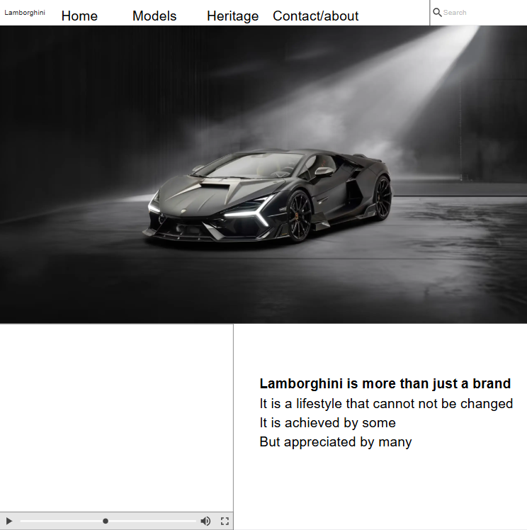
This will be the main page/ home page that will initially be open at the beginning to provide the user with basic information about the website and a hero page.
The second and third pages will consist of the current models and heritage models that Lamborghini has and had.
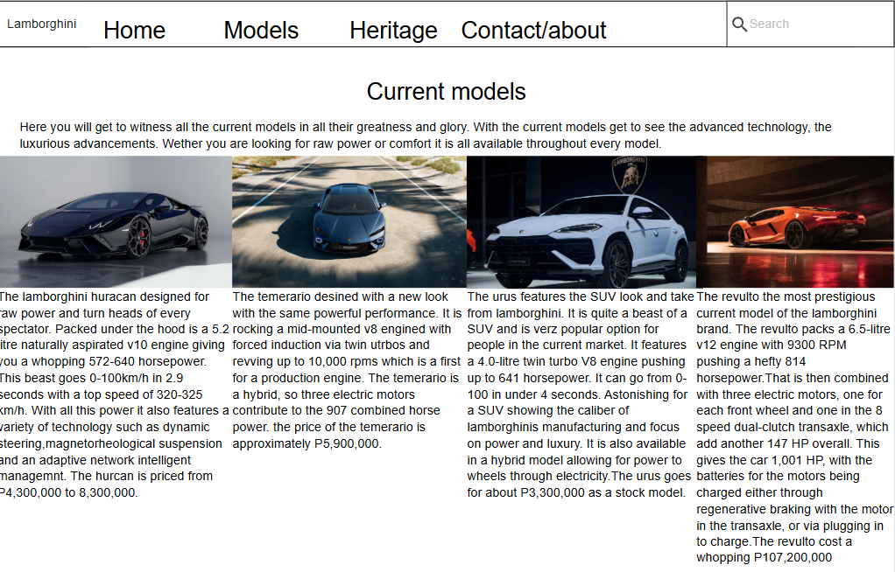
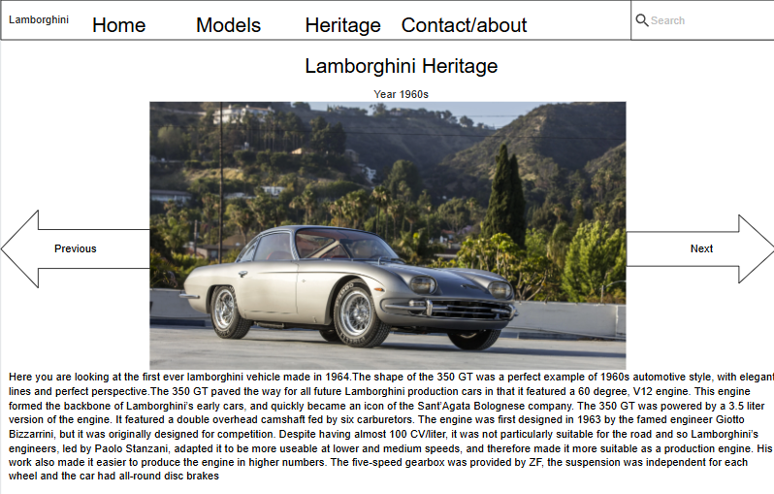The fourth page will be about the heritage of Lamborghini through the years
The final page will be a simple contact us wireframe to allow user to contact me and find means of communication.

